Replacement Lab #14

Directions: View the images below and answer the following for each:
- What pathology is shown in the photo?
- What causes the pathology shown?
- What are some ways this pathology presents its self in the skeleton?
A.
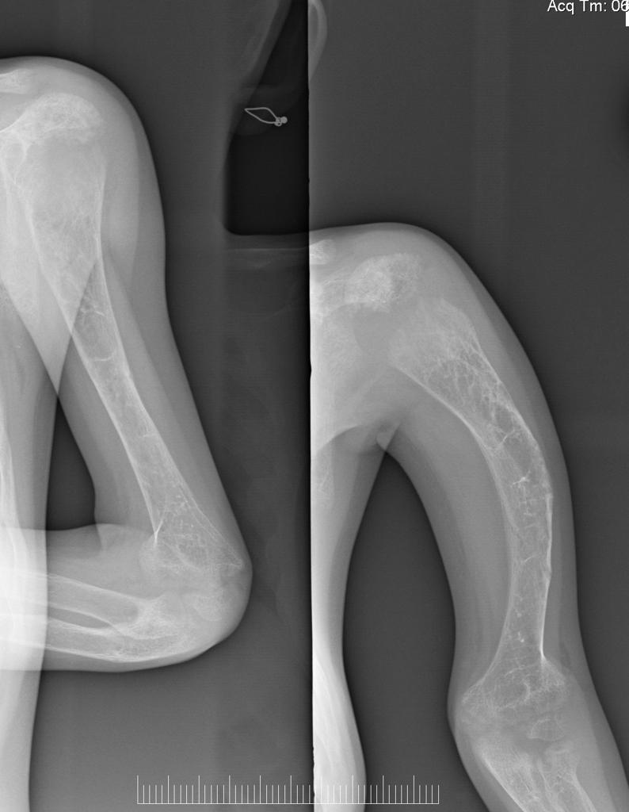
1.
2.
3.

B.
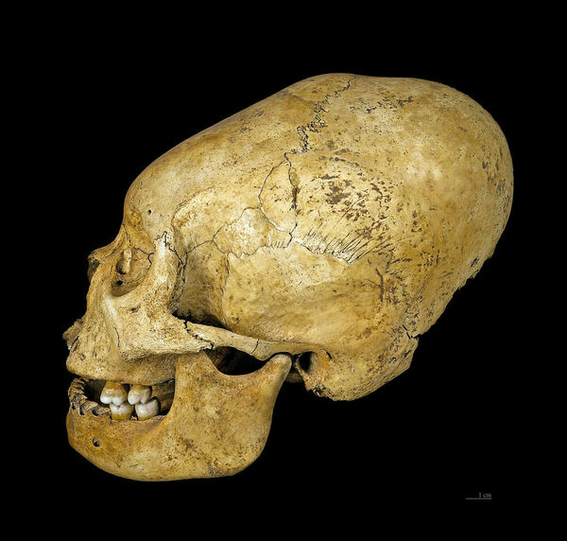
1.
2.
3.

C.
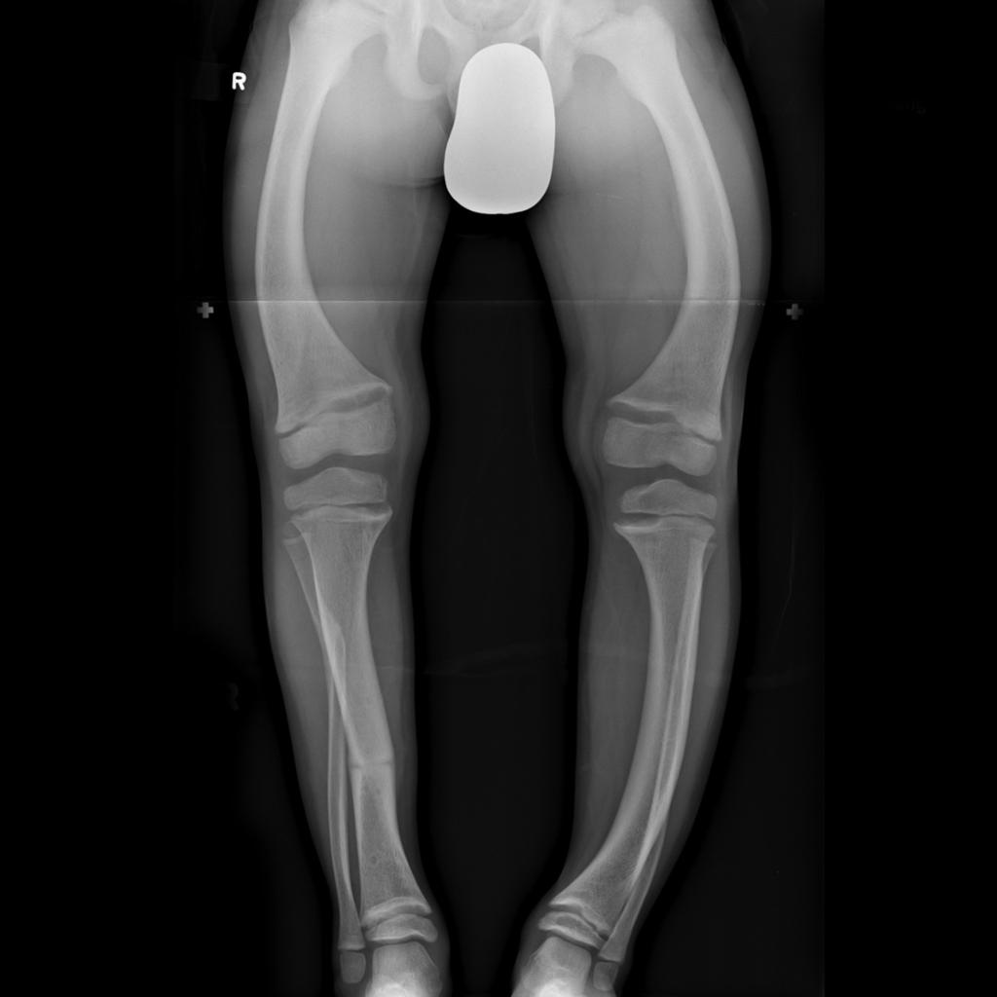
1.
2.
3.

D. These 2 images show the same thing.
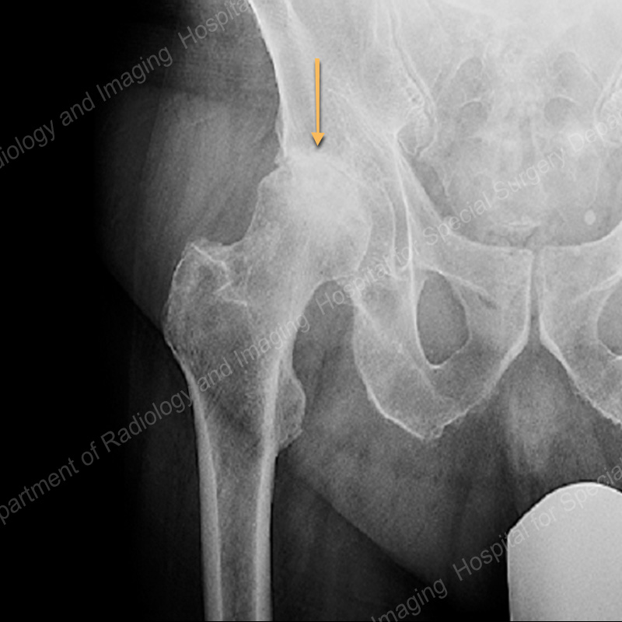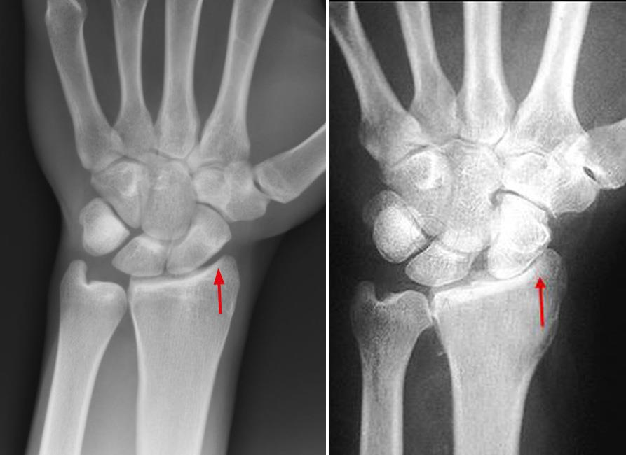
1.
2.
3.

